VideoANT
How to Give Written Feedback on a Student’s Video
1. Go to this link: http://ant.umn.edu
2. Open VideoANT by clicking “Launch VideoANT”
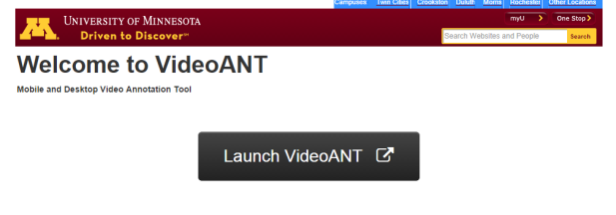
3. Register (Sign-in). It is really easy if you sign in with your Google/Gmail account. You can sign in as a guest, but you will not be able to archive your projects as a guest.
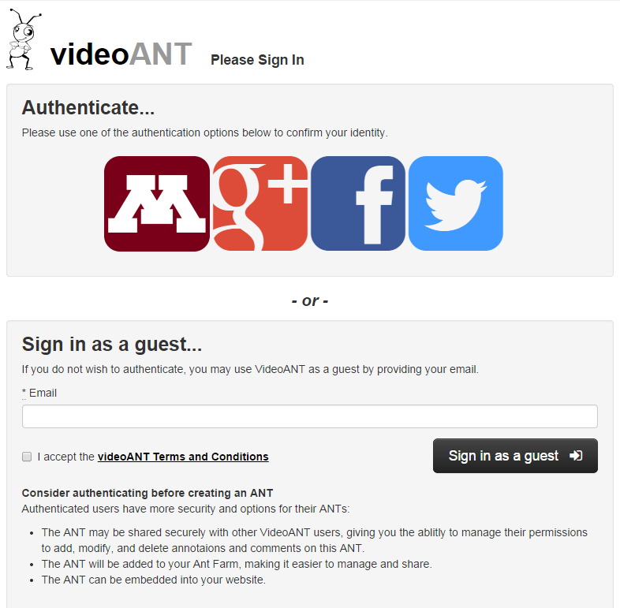
4. Click on “New ANT” if you are making a new videoANT. The “ANT Farm” is where you find all of your previous projects.

5. You need to upload the student’s video file to YouTube and then upload the YouTube video to VideoANT. To upload to YouTube, go to YouTube.com and click “upload”.
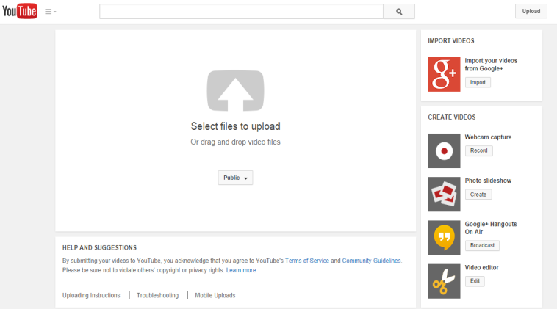
6. In YouTube, select the privacy setting as “unlisted”. This allows only the people who have the link to view/edit the VideoANT. The “private” setting is possible, but permission will be needed.

7. Now, you need to upload the video from YouTube to VideoANT
Two methods for doing this:
Method 1: To Begin Annotating a video:
- Enter the video’s URL or YouTube address in the “Video URL” field
- Click the “load Video” button
- Give your ANT a title
- Click the “Start Annotating” button
Method 2: Alternatively, if you are signed in through Google:
- Click the “Browse YouTube Uploads” button to browse a list of your YouTube Uploads
- Click the “annotate” button under the video you’d like to load
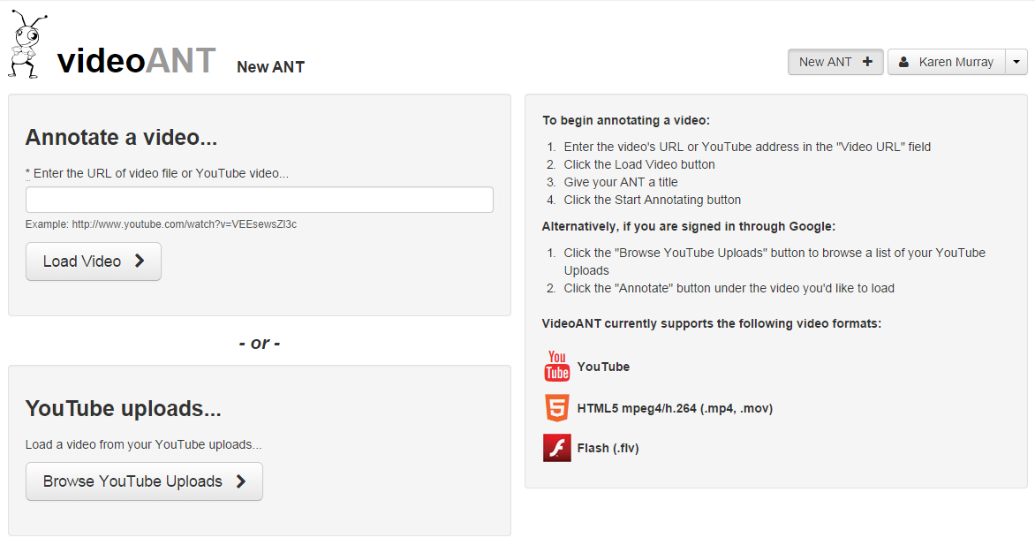

8. Begin Annotating!
Steps:
- To begin the video, press ‘play’.
- To make an annotation, click “Add an Annotation”
- Type in a subject/title of annotation
- Add an annotation
- Click “Save Annotation’ or click ‘cancel’ to leave
- To skip ahead, click anywhere on the timeline to move the video forward or back
7. To edit/delete an annotation, click the dropdown arrow on the right of the comment.
8. To share your videoANT, just copy the URL from the top of the browser and share it. Anyone who
has the link can watch, annotate and comment on previously made annotations.

Type your comments in here.
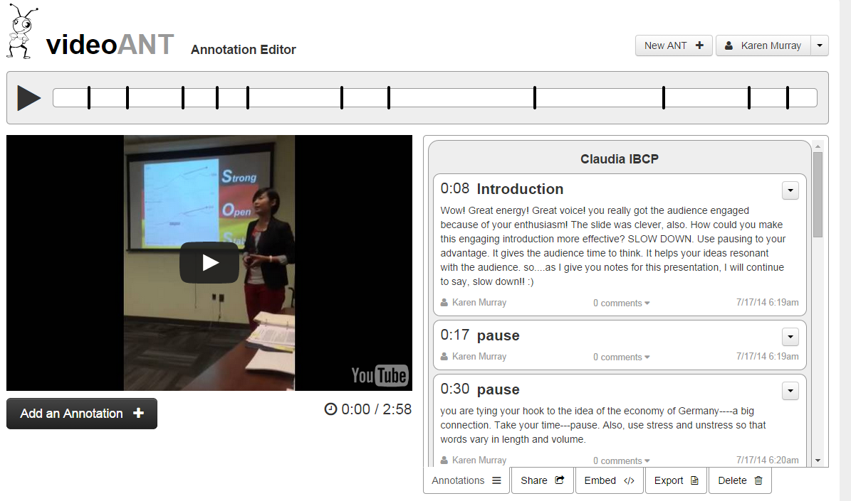
You can stop the video at any point to add a comment.
First, click “play” and then click here when you want to add an annotation.
At the end, be sure to share your VideoANT

