Twiddla: a no set-up web-based collaboration playground
"Mark up websites, graphics, and photos, or start brainstorming on a blank canvas. Browse the web with your friends or make that conference call more productive than ever. No plug-ins, downloads, or firewall voodoo - it's all here, ready to go when you are."

Get Started
Go to www.twiddla.com and click on "GO: Start a new meeting"
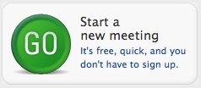

Whiteboard
Twiddla will open to the whiteboard. Across the top, you'll see a great set of tools [1]. You can change from a plain background to one with gridlines. You can easily add a web page, document, or image as a background to markup. There is a color palette tool, a draw tool with different widths, a shapes tool, and a text tool. EtherPad (a multi-person editor for collaborative writing) is also included. To the right you'll see options to use audio [2], to copy a url link that you can share with students [3], and a chat box [4].
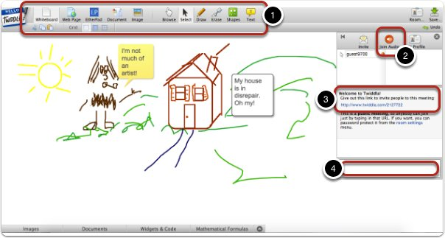

Webpage, Document or Image Background?
Click on one of the options across the top of the page (Web Page, Document, or Image) to markup. It will take you to the "Background Chooser." Here you'll add the URL, or upload a PDF or Image.
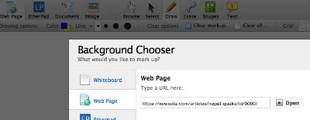

Webpage or a PDF document
Mark up a webpage by adding highlights, comments, drawings, etc.
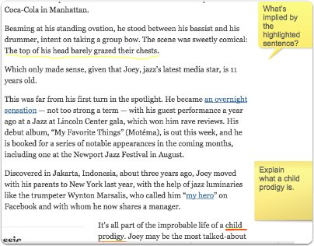

Mark up an image
Marking up an image is also possible. Students have all the same tools, drawing and text entry tools, to make comments on an image file. (This image came from 601 Core class. Students are taught about the rules of art for ancient Egyptian artists. You could upload another image from that time and have students point out how/in what ways the artist followed those rules.)
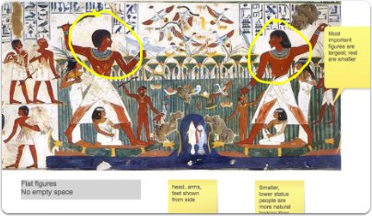

EtherPad
EtherPad is a web-based collaborative tool allowing writers to simultaneously edit a text document and see everyone's edits in real time. Each writer's text is highlighted in a different color. This tool has also been available in Canvas through "Collaborations," but it will no longer be available after June 6, 2015. The tool is still available on Twiddla. (On Canvas, students can Collaborate through Google Docs if they have a SAS Google account or a personal Google account.)
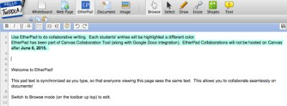

Save a Snapshot
Using the "guest/no signup" mode, you cannot automatically save a snapshot of your screen, but you can use the Snipping Tool (Accessories folder on your PCs) or other screen capture tools to take a screenshot of the marked up documents /webpages.

