Using Turnitin with writing assessments
Turnitin can help students avoid unintentional plagiarism and help teachers become more aware of how students are using source material in their texts. Turnitin can easily be used with any writing assignment submitted through Canvas.
Setting it up in Canvas:
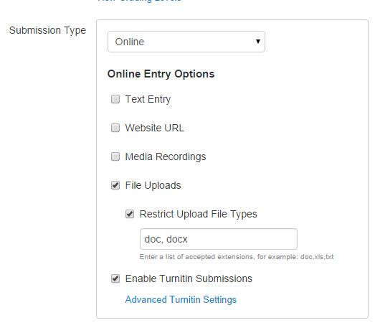
When you set up your assignment in Canvas, click “Enable Turnitin Submissions.” It’s also a good idea to restrict file types to Word documents.

Advanced Turnitin Settings:
If you allow students to see the Originality Report as soon as they submit, they will be able to notice any accidental plagiarism or unsuccessful paraphrases in their texts.

If students are submitting multiple drafts, it’s a good idea NOT to include the first draft in the repository. (If you include all drafts in the repository, later drafts will be flagged as plagiarized versions of the first draft!)
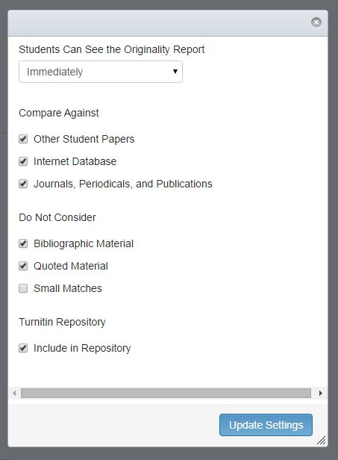

Sample Originality Report:
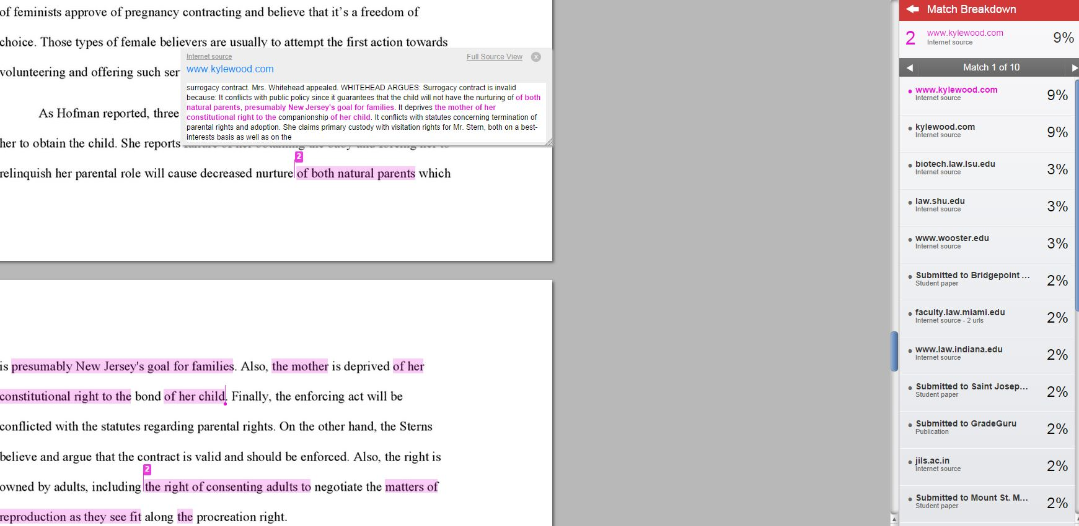
If a student’s text matches an internet source, you can compare the wording on the internet to the student’s. You can click “Full Source View” to visit the site.
NOTE: If a student’s text matches a paper in Turnitin’s repository, it will be flagged but you will not be able to see the original paper.

